ST PETER’S

ELLERSLIE-MOUNT WELLINGTON

PRESBYTERIAN CHURCH

ANNUAL REPORT

2020 - 2021

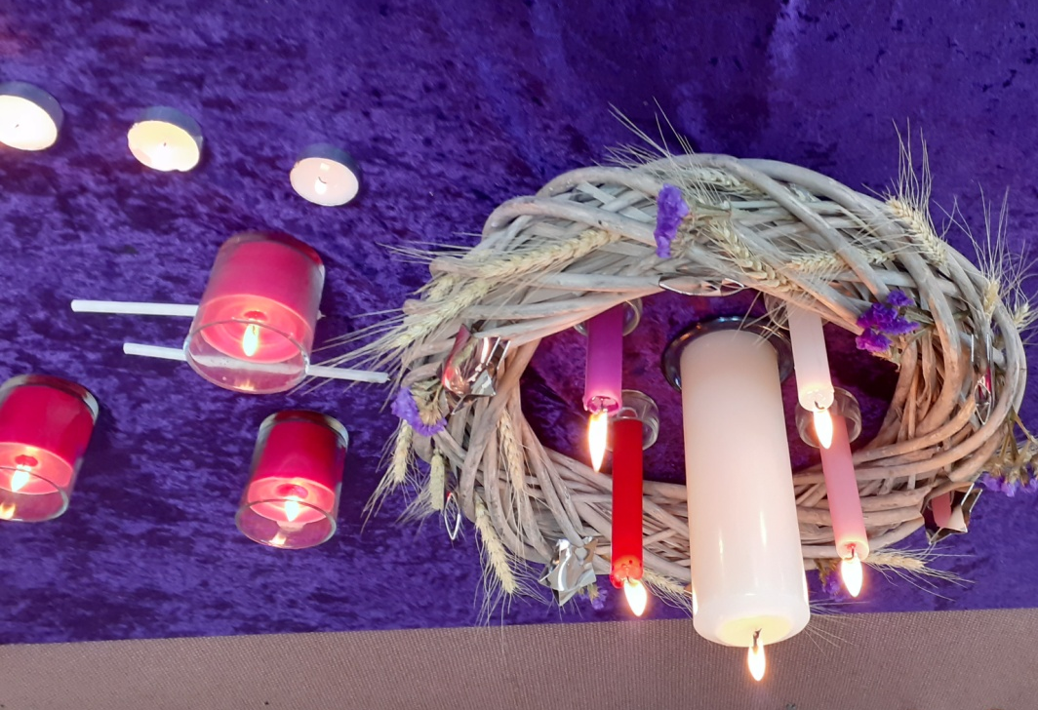

Minutes of the 2019 Annual General Meeting
Held 3 November 2019
Present
Owen Jones, Nats Levi, Anne Clarihew, Mary Matthews, June Brundell, Maureen Fausett, Wally Davison, Shirley Davison, Susan Jones, Isobel Clarihew, Dorothy Brockett, Stewart Arnett, Betty Brown, Nola Taylor, Irene Bicknell, Sue Lys, Deborah Hopkins, Stephanie Yee, Andrew Yee, Filipo Levi, Gary Misiniu, Jen Misiniu, Eddie Fuatimau, Janet Fuatimau, Catherine Watkins, Greg Watkins, Roxy Gahegan, Anne Graydon, Lagi Laban, Val Shepherd.
Apologies
Miles Dillon, Bethany Carter, James Carter, Brett Johnstone, Kimberley Jones, Ben Jones, Maia Sharpe, Bert Laban. Moved: Stewart Arnett; Seconded: Owen Jones; Agreed.
2018 Minutes
Minutes of the 2018 Annual General Meeting as distributed were taken as read. Moved: Anne Graydon; Seconded: Stewart Arnett; Agreed.
Annual Reports
It was moved that the reports as distributed be received en bloc and taken as read. Moved: Anne Graydon; Seconded: Irene Bicknell; Agreed.
Parish Council
Silence was observed for Trish Hill, Ann Carn-Bennett and others who have died during the year. Anne Clarihew thanked the Parish Council for their work during the vacancy with thanks also to Roxy and Mark Gahegan for their contribution. During the course of the meeting Shirley Davison thanked everyone for making her and Wally feel welcome to St Peter’s.
Minister’s Report
Owen Jones asked what will happen at the end of Roxy Gahegan’s stated supply contract. Roxy said it was open-ended and renewable. Owen expressed gratitude for the great job Roxy has done. We will need to work out the best way to journey forward. All feedback to this end, both good and bad, will be most welcome. It is good having children’s talks each week.
Cook Nights
Debbie Hopkins urged everyone to not hesitate to mention people who need a meal.
Prayer Chain
Debbie Hopkins offered to pick up anyone who does not drive but who would like to attend Prayer Group meetings. Catherine Watkins said that it is amazing to answers to prayer.
Property, Finance, Health & Safety
Owen Jones thanked all those who attended the working bee and asked people to speak up if they find anything needing repair.

mainly music
Thanks to Owen Jones, Lagi Laban, Roxy Gahegan for joining the team. Thanks too to Val Shepherd for cleaning the toilets and washing the floors after mainly music. 31 families are associated with mainly music and, while there are seasonal fluctuations, attendances average from 20 to 30 people per week.
St Peter’s Youth (SPY)
Great feedback from parents about the great work Beth Carter has been doing. Anne Graydon commented that Parish Council hopes to focus on youth during the coming year, actively trying to nurture and support the young people. Members were encouraged to pray for and support our youth.
Sunday Funday
Catherine Watkins said that a number of the youngsters are moving on to SPY and reiterated Anne Graydon’s comments about praying, supporting and being involved with the children. Roxy Gahegan said that meeting the needs of children often meets needs in ourselves.
Staycation
To be re-evaluated for 2019/20 – maybe one night only. Debbie Hopkins said it is fun and relaxing. Anne Graydon stated that the Saturday night dinner is a good opportunity to come and support the event.
Walking Group
Irene Bicknell, Wally and Shirley Davison joined last week. Walks take place every Thursday at 9am at Thompson Park – open welcome to anyone interested. Wally said he was not aware of the group until he read about it in the annual report – publicity needs to go into the newsletter.
Worship Team
Thanks to Mark Gahegan, Tom Hopkins and Liam Watkins for their contributions. Thanks also to Michaela Fuatimau and Olivia Hopkins for their lovely singing. Stewart Arnett’s 30 years of loyal service as organist was acknowledged with gratitude.
Treasurer’s Report
Thanks to Eddie Fuatimau, Andrew Yee and Greg Watkins for all their work. Owen Jones suggested people might think about giving their taxation refunds back to the Church. Andrew Yee commented on the decline in offerings and urged people to consider their offerings with prayer. We need to be more intentional in our fundraising efforts during the year ahead and to this end it is hoped to have more fundraising events. Cook Night – error in the 2020 Budget expense figure which should read $1000 rather than $5000. Rates reduced in 2020 Budget due to relief offered from Auckland Council for the 2020/1 financial year.
General Business
Roxy Gahegan was again thanked for her contribution and efforts.
The Ministry Settlement Board has been gathering information to update the Parish Profile. There is a meeting on 7 November so there will be an opportunity to provide an update.
The Annual General Meeting concluded at 11.40am with those present saying the Grace.

Parish Council Report
The retrospective nature of this Annual General Meeting reflects the impact of COVID19.
Fortunately prior to these events the Parish Council had been able to delegate a lot of business previously spent on property and health and safety matters to the reconstituted committee. This allowed the eldership to focus on the key issues of pastoral care and future direction of St Peter’s. It has been a delight to ordain Lagi Laban to the eldership team. The Parish Council now comprises: Rev Roxy Gahegan (stated supply minster and interim moderator), with the serving elders June Brundell, Anne Graydon, Lagi Laban, Filipo Levi and Andrew Yee.
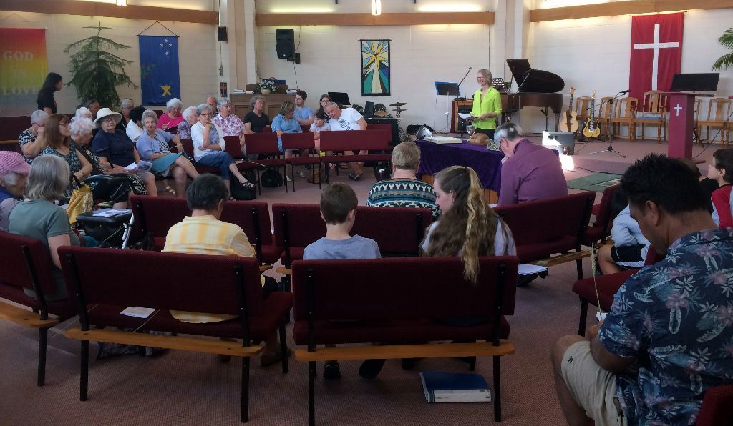
The Parish Council requested Roxy to use the current vacancy to explore and experiment with change. Little did we realise that some of this would be beyond our control. During lockdowns members rapidly adjusted to gathering for worship by way of Zoom online meetings. Roxy and her husband Mark implemented such meetings and their efforts were greatly appreciated. Members were invited to ‘sit with’ and contemplate the lectionary readings and reflections prior to Sunday sessions. It was particularly enriching to have all ages participating in Zoom meetings and breakout discussion groups. However, warm social gatherings, not to mention the aroma of sausage rolls, were greatly missed. Pastoral connections took on broader and heightened significance with people checking in on each other via phone, text, mailbox drops and distance visiting. Sadly we seem to have lost one or two regular attendees due to the lockdown dislocation, but with whom we are still in contact.
We treasure the creativity, depth, richness and fresh perspective of Roxy’s preaching. She has encouraged members to engage personally in individual faith practices. We have enjoyed a variety of services and during January 2021 Taizé-style contemplative services, held in the lounge, were positively received.
The Ministry Settlement Board has met regularly and worked hard to produce the Parish Profile which was approved by the congregation and Presbytery. The ministry position has been advertised and steady pleasing progress is being made.
Within the Northern Presbytery all parishes are being assessed in terms of their ongoing viability with a view to restructuring faith communities suited to the era in which we live. St Peter’s, located in a growth area but one of relatively high needs, faces some significant challenges. The Parish Council is planning two elders’ retreats to prayerfully examine our present situation and discern the way ahead. Following this the entire congregation will be invited to engage in a united process of discernment and subsequent action. It is vitally important that all members join together in shaping what we hope and pray will be an exciting step in the life of our faith community. We seek to be proactive in tailoring this to our congregation rather than passively embracing and allowing the status quo to lead to decline.
COVID 19 has taught us valuable lessons in coping with and adapting to change from the deeply personal to the global. In the parish’s 140th year, a similar spirit is called for in the ongoing pilgrimage of St Peter’s, Ellerslie Mount Wellington Presbyterian Church.
THANK YOU, EVERYONE! YOU MATTER!
WITH GOD WITHIN, BETWEEN, BEFORE AND BEHIND US
LET US JOURNEY IN HOPE.
Anne Graydon, Parish Clerk
Minister’s Report
The Presbytery Context
Looking back over the past year, it is like surveying a whole new landscape which suddenly and unexpectedly erupted into the rhythm of our days. The pandemic has overshadowed every aspect of our lives and our way of living. However, before the pandemic, there was a focussed effort by the Northern Presbytery to address the issues of decline in church attendance and in ministers available to lead.
There was a push at the regional presbytery meetings for us to recognise a widespread and ongoing pattern of once larger but now small congregations losing the energy and vision to maintain the church buildings and losing the will and imagination to engage in any significant ways in the communities beyond the church fellowship.
Many of the churches in our region had become focussed only on keeping going the way that they had been for the last fifty years or more, and although there was a background awareness that this cannot be sustained indefinitely, there was also a deep-seated unwillingness to recognise and address this reality.
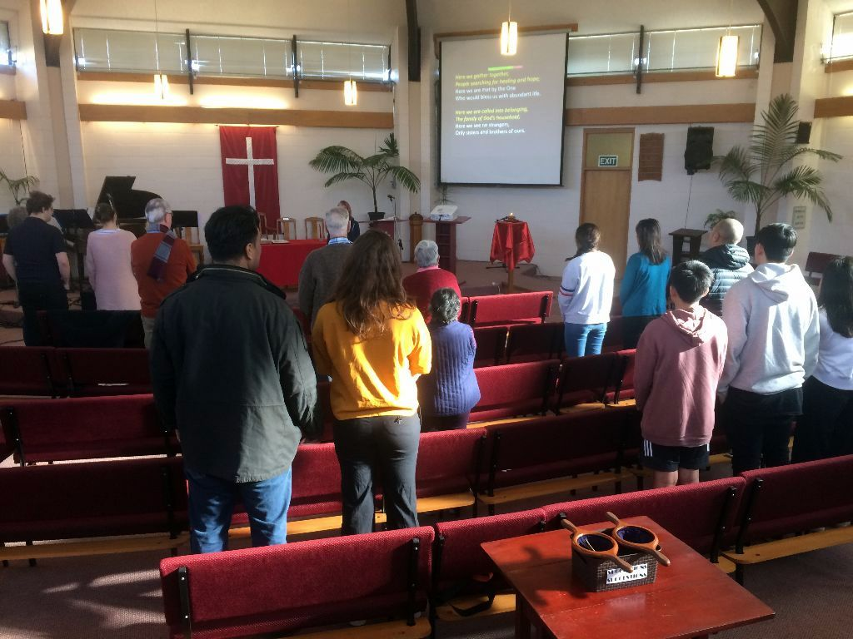
Northern Presbytery decided that what was needed was something that forced the issues into the open, so that we could properly examine them and then come up with a strategy that would bring change and lead us toward a vibrantly growing servant church community.
So, prior to the pandemic, a workgroup was tasked with forming a framework for measuring and assessing the general health and viability for the future of all the churches in the region. Each congregation was given a grade indicating their relative potential for sustaining a community of worship and service and their vulnerability relative to funds and human energy security. How much do we have to draw on financially? From the ages of the congregation, what are the likely human resources available within the church roll? Also taken into consideration was how many other Presbyterian churches were within a reasonable travelling distance, indicating that, from a geographical and practical perspective at least, consolidation with and integration into other nearby congregations made much more sense than allowing multiple struggling churches to continue to function with depleting resources.
I think it’s worth mentioning that this measure does not reflect what a congregation may have to draw on in terms of imagination and creativity, relationally and spiritually.
Also worth mentioning is that there are minimum requirements for a congregation to meet, set out in the Book of Order, in order to be accepted as a viable Presbyterian church. Those congregations whose assessment revealed them to be unable to meet the minimum requirements (according to the Book of Order) for a worshipping community would be led in a process of evaluating the options. The options, in case you are in any doubt, are essentially binary – merge with another congregation or dissolve the church and find other places to worship.
At the end of 2019, St Peter’s was given a B/C+ rating indicating that it was seen as at the vulnerable but not endangered level. The rating recognised the value of land assets and liquid assets, the number and age range of people in regular attendance and the number of other nearby churches (two – Greenlane and Somervell).
Then came COVID.
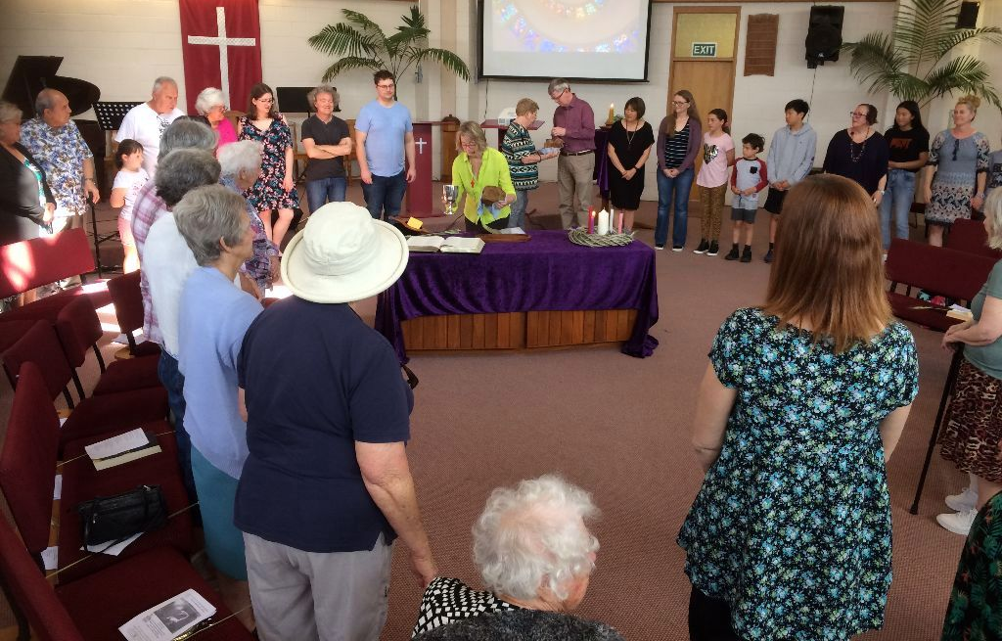

Stated Supply Ministry
In the first year or so of my time with you, I had presented you with some adaptive change challenges. I moved the furniture around. I introduced different kinds of prayers and candles and re-introduced some Taizé songs. I told stories and asked questions, set up interactive stations and invited you into conversation. There were some mutterings as well as some appreciation.
COVID presented us with another adaptive challenge but on a much larger and longer scale. There was no choice here, we simply had to adjust, adapt and at times abandon normal living and ways of being. There was less muttering about this.
Most of us learned how to use Zoom and, especially at first, it was really heartening to be able to still see and talk to each other. It was not church as we were used to, but it did fill a gap – a big gap – that physical distancing forced upon us. We were also more keenly aware of how we support each other socially, emotionally and spiritually and many of you made extra efforts to ensure those connections were living and real.
Over successive lockdowns, there has been a waning of enthusiasm for these extra measures and the appreciation for Zoom has worn thin by now. I think this is a widespread phenomenon.
On returning to the building and to ‘normal’ there is a natural - but not necessarily healthy- desire for everything to go back to the way it was. This is understandable. In times of transition, we do need zones of safety and security.
And this is in part where the tension lies.
Many of us want to stay in the comfort zone for every part of life.
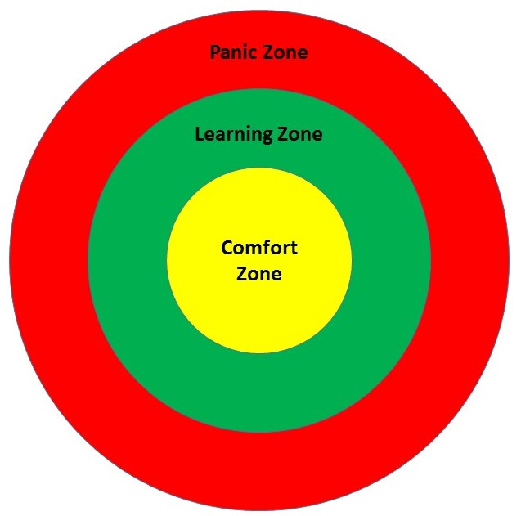

Sometimes it seems like faith and belonging to a church has been offered as a way to achieve this. You may have been given the expectation that nothing will truly overwhelm you because you have God/faith/the church to support you and keep you safe.
I note that Jesus clearly did not expect this to be true for himself or for his disciples.
But still for many, church becomes the place that does not change or challenge or ask anything too much of you but is instead the place of refuge and reassurance. The confusion here is that faith does offer us the ultimate safe space, the ultimate assurance of our belonging and belovedness, but it is within you and not in the building, the form of worship or the group of people who meet regularly.
Teresa of Avila, a reforming nun of the 15th century wrote about it like this:
“There is a secret place. A radiant sanctuary. As real as your own kitchen. More real than that. Constructed of the purest elements. Overflowing with the ten thousand beautiful things.... This magnificent refuge is inside you.
Enter. Shatter the darkness that shrouds the doorway… believe the incredible truth that the Beloved has chosen for his dwelling place the core of your own being because that is the single most beautiful place in all of creation.”
This inner sanctuary is the unchanging faithful love of God in you and the cosmos, and the invitation of faith is to learn to be at home within it.
If church is your source of safety you will resist anything that seems to threaten it, which means church is no longer a place where you are stretched, a place where you learn and grow –the comfort zone is not the learning zone.
It might be that listening to a sermon you do learn something new, an interesting piece of information, but chances are it isn’t something that really stretches you and asks you – pushes you – to change in any real way.
It is also worth noting here that as we age, the comfort zone actively shrinks, so what we may have been open to exploring and experiencing in our younger years no longer falls in the stretch zone of learning, but in the panic zone where we are driven by fear and the need to retreat or attack as a matter of self-preservation. In the panic zone, we become more prone to circling the wagons around what we know and more likely to perceive the unknown as a threat. Again, this is a natural but not necessarily healthy reaction and while it ‘happens’ there is always the opportunity to learn to see the reaction and choose not to let it guide and limit you.

The Year Ahead
So, looking ahead, it seems important to be aware that how you greet change, how you accommodate what is unwelcome, unfamiliar, unwanted – this says something about the expectations you are bringing to the community and about the underlying values that guide how you personally engage with others, and how you as St Peter’s engage with those in the wider community.
It also seems important to mention something about hope. Hopeful communities feel engaging and inviting. There is buzz and joy that has depth and breadth – a capacity to hold tension with grace and a willingness to honour and celebrate difference. We can spot this even if we can’t explain what we are seeing or feeling.
Hope is broad and open ended, it is creatively open to possibilities. If that sounds fuzzy, it may be you have been confusing hope with expectation. Many of us use the word hope when we really mean expectation. We may say, “I hope you get that job”; “I hope you feel better”; “I hope it rains”. We are expressing a wish for a particular outcome over which we do not have much control beyond our wishing for it. Hope is much more gritty that this, asks much more of us than a fixed idea of what is needed, what is good, what is acceptable. Hope asks us to trust that we will be given or find within us the resources we need to navigate whatever comes. Hope asks us to be open to creative solutions to situations, even surprising solutions. Hope needs to be given a wide horizon so that unexpected gifts may arrive and be recognised rather than dismissed or rejected.
A hopeful community sees the possibility within and focusses on bringing these forth rather than fixing problems or following a programme with particular expectations to chase particular results.

What does all this say for the future of St Peter’s?
Whoever is called to minister here will need to take the Presbytery rating into account for the journey ahead. The mainstream churches in New Zealand and around the Western world are all facing the same reality of declining attendance and a loss of cultural significance. That sounds negative, but we do not have to approach the situation with anxiety. We do not have to focus on what is gone and ask ‘how do we get it back?’ or come up with a plan to resuscitate an institution that appears to be in cardiac arrest.
Death and resurrection are the story we have to tell, they are in our DNA. Life is God’s gift to the cosmos, abundant life. A full measure, pressed down and overflowing. The God we put our trust in is not short of resources, and so neither are we.
In order to shift the focus towards a future with hope and fullness of life, there are important and foundational questions that need to be explored and reflected upon both at a personal and at a communal level. These questions are multi-layered and so it is challenging to answer them fully and honestly. It will take time, patience, compassion and courage to come to the whole truth. It will be tempting to go only halfway and accept partial and superficial answers to avoid the trouble of conflict or of acknowledging uncomfortable realities.
In exploring these questions, there needs to be the opportunity to listen to each other and to understand where each one is coming from so that a sense of shared values and shared vision can emerge.

A Few Questions to Get You Started:
What is the purpose of the church community? Who is it for and who does it serve through activity and engagement?
What values are at the heart of the community and how are they held, communicated and embodied?
What are you hoping for and how are you hoping it?
There are many changes in store. The future is full of possibility, each moment a chance to open to the flow of love and grace. The incredible truth is that God has chosen the core of your own being as a dwelling place. There is always a safe refuge within, no matter what is happening without.
There is every reason to be hopeful.
Grace and peace
Roxy Gahegan
Property Finance Health and Safety Report
The Property Finance Health and Safety Team met sporadically through 2020 due to COVID 19 disruptions. Despite this, we have managed to fill two skips with material from the petrol station and manse, construct compost bins using some of the old fence palings and collect 57 conference chairs that were donated from a local business whose lease had expired.
The commercial tenants in the manse, Family Works moved out and the property was reinstated as a residential tenancy with new linoleum, kitchen oven and shower. New tenants, a family of four have moved in and are happy with the premises. In December we employed the services of property managers, Ray White for the manse.
The gardens around the church have been well maintained with new planting on the street front and down the side of the church by Miles Dillon and the Jones family. We are grateful to have the Ministry of Corrections team mowing our grass around the premises on a regular basis and would like to thank Filipo Levi and Roxy Gahegan for their ongoing commitment in communicating with the Corrections team.
Sadly, our tenants in the church foyer, Immigration Services served their notice late in 2020 and we are looking for new occupants for the two rooms they occupied.
Owen Jones is in the process of registering donations for 2020, issuing tax receipts for donations received by automatic payment and by now you will have received donation envelopes for the next financial year.
We have nine high priority items for action that we will look at funding through grant applications. The team would like to extend a huge thank you to everyone for their efforts over what has been a challenging year and will continue to work on the priorities identified.
The PFHS Team (Andrew Yee, Gary Misiniu, James Crater, Owen Jones, Stephanie Yee)
Sunday Funday Report

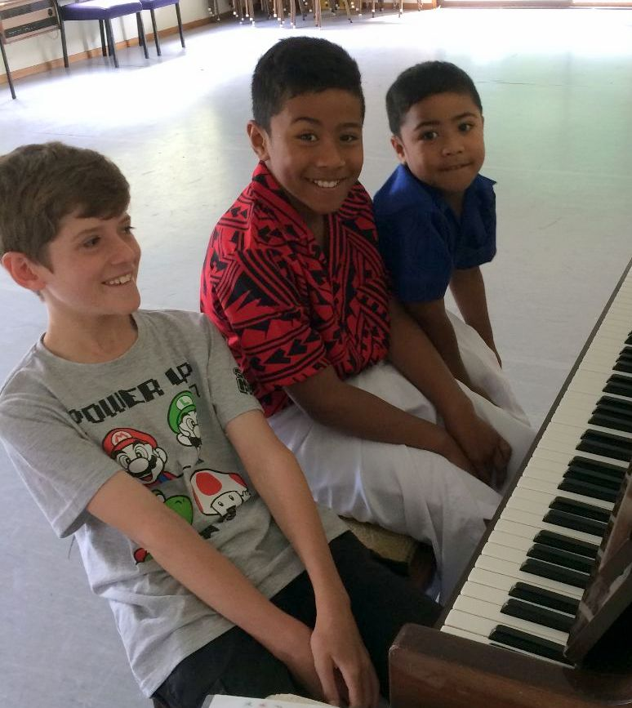
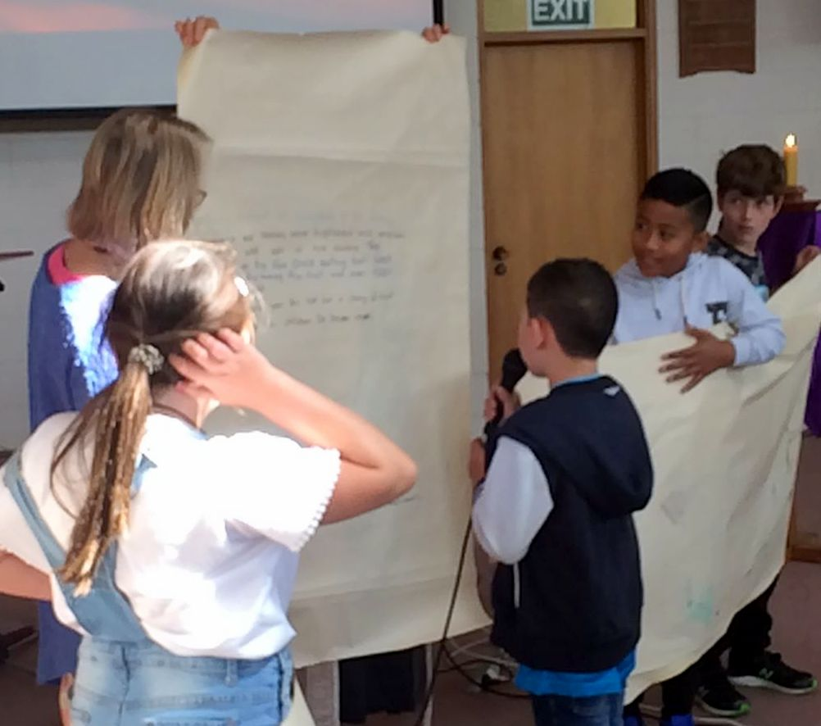
Children are active participators in our Sunday morning services. They are keen welcomers in the foyer, handing out the morning bulletin sheet, carriers of the Bible into Church, Christ candle lighters, singers in the Worship Team, whipping round gathering the offering and participating in Communion. We continue to host five families with an average of ten children attending Sunday Funday on a regular basis. We welcomed the Korean family with three boys; Jiwon, Sowon and Joowon to Sunday Funday and sadly farewelled them as they left to plant a Church at the end of 2020.
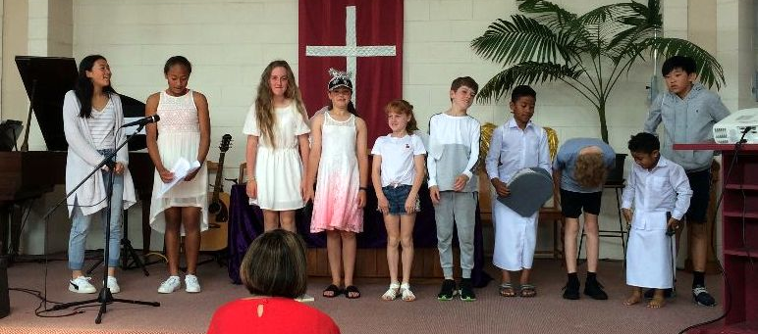

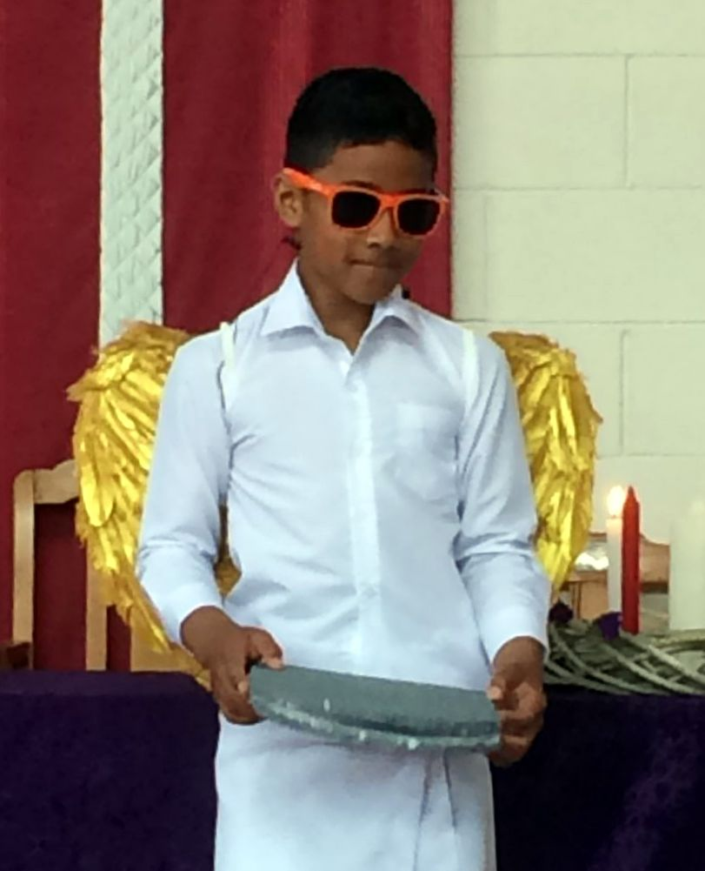
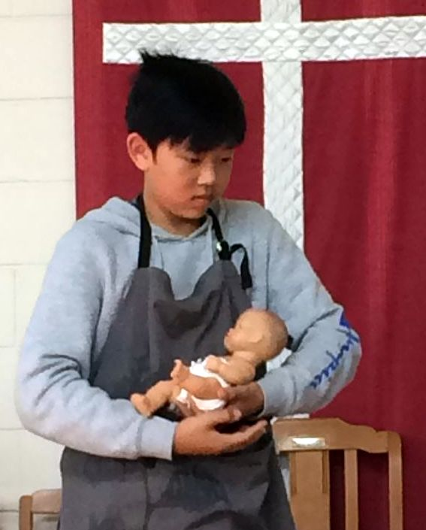
In our face-to-face services the children’s talk was reinstated which was enjoyed by all the congregation. Hospitality sessions were organised once a term where the children prepared and served morning tea in the spirit of respecting our elders and being servants of Christ.
During lockdowns, children participated in online Church and in the breakout rooms where adults enjoyed their perspectives on Scripture and life. A big thank you to Miles Dillon, Debbie Hopkins and Linda Harper who volunteered to take some sessions while Stephanie Yee wrapped up her studies in the latter half of the year where they stepped in with some creative and inspiring sessions.We faced much disruption in 2020 and our main aim was to continue to provide a safe space for children to raise any topic or issue. We are glad to have 2020 behind us and look forward to implementing some of our plans we had for last year in the forthcoming year.
Blessings – Catherine Watkins and Stephanie Yee
mainly music Report
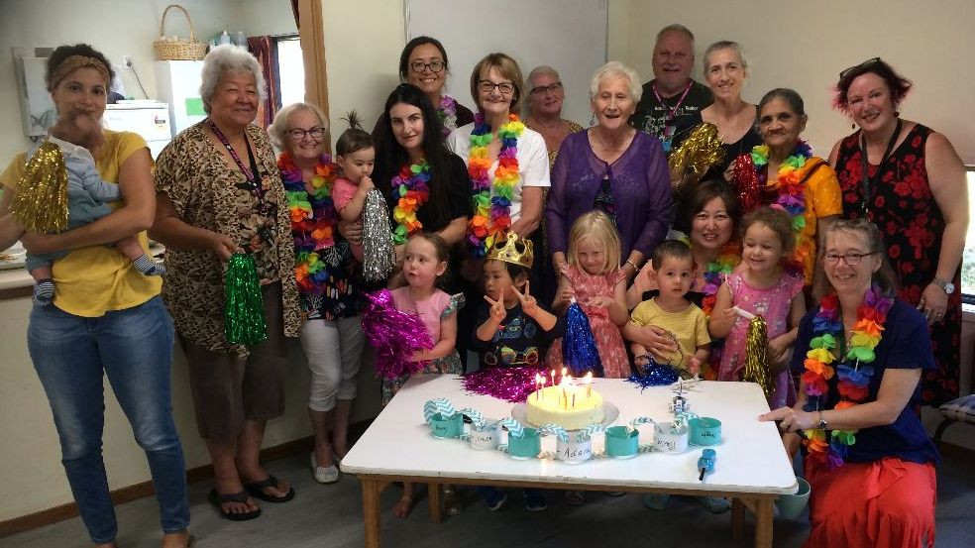

2020 saw Ellerslie mainly music celebrate its 15th anniversary! Numbers have been well down on prior years.

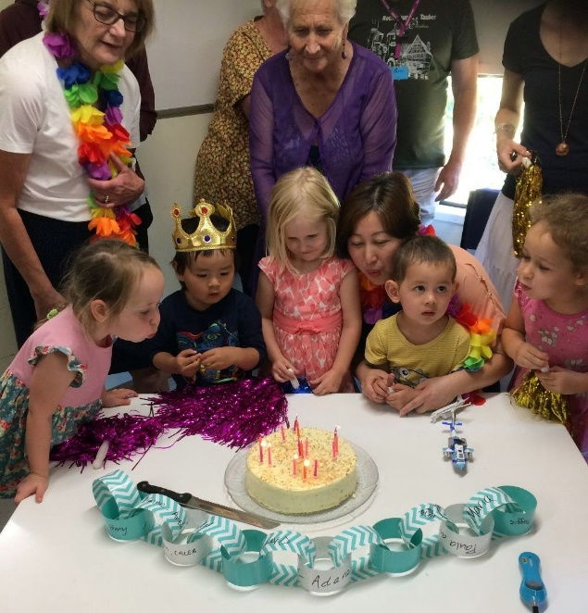

The leadership team comprises Anne Graydon, Gay Kee, Lagi Laban and Miles Dillon. Owen Jones is taking a break at present and Debbie Hopkins’ assistance from time to time is greatly valued. Roxy Gahegan attends most sessions, her inspirational talks meeting with an attentive hearing.
Lockdowns last year disrupted our programme and after a short delay at the start of 2021 we are under way once more. Many parents and their offspring form friendships which endure beyond the mainly music years, and we, the leadership team still meet occasionally with former members.
Despite the disruptions we are committed to continuing this outreach ministry of St Peter’s.
Miles Dillon, sideline High-Fiver

